**MINOR PROJECT REPORT**

**ON**

**HOTEL MANAGEMENT SYSTEM**



**BACHELOR OF ENGINEERING**

**In**

**Computer Science and Engineering**

**SUBMITTED BY**

**Group no.- 2(G6)**

HIMANSHI TICKOO (2021A1L009)

SIMRAN RAINA (2021A1L013)

NEHARIKA GOSWAMI (2021A1L001)

AGRIMA SHARMA (114-CSE-17)

**Model Institute of Engineering and Technology**

**Kot Bhalwal, Jammu - 181122**

**www.mietjammu.in**

**Contents**

|  |  |
| --- | --- |
| S.NO. | TOPICS |
| 1. | What is Hotel Management System |
| 2. | Features of Hotel Management System |
| 3. | Steps to create a Hotel Management System |
| 4. | Source Code with output |
| 5. | References |

**What is Hotel Management System Project in Python?**

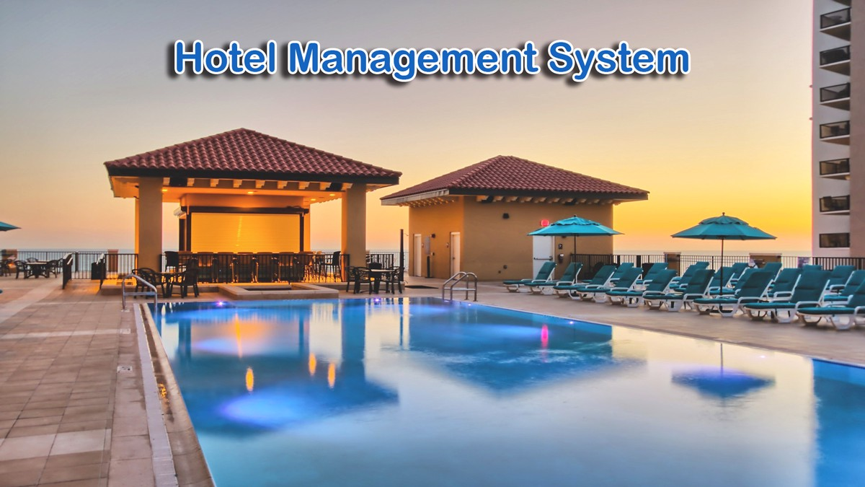

## What is hotel management?

Hotel management is an area of the hospitality industry that involves overseeing the operations of a hotel location. When working as a hotel manager, you may manage the operations of a motel, resort or another similar establishment that provides lodging and other services for guests.

The title, "hotel manager" often refers to a hotel's general manager, who serves as the head executive at a specific property. The duties assigned to the manager depend on the size of the hotel, as well as its purpose and the expectations of its owners. A general manager at a hotel receives support from department heads, who oversee their own employees and report on the key functions.

The **Hotel Management System Project in Python** is a general software developed (using Python) to simplify hotel operations by automating them.

## **Features of Hotel Proect**

## **Features of Hotel Management Python Project**

A **Hotel Management Python Project** It covers major aspects of hotel management; it could perform the following operations*.*Hotel Booking, Provide you with Hotel Rooms Info*,*Room Service*,*Billing and Record-Keeping*.*

### **1. Hotel Booking**

* Function to book a room in a hotel by entering information about the user or customer.

### **2. Room Management**

* These features manage all the information of the rooms in the hotel.

### **3. Room Services**

* Function that user has to select and give **users** and **customers information** about **hotel rooms** (i.e., about room amenities).

### **4. Billing and Record-Keeping**

* At check-out, there is a function that lets you pay for your hotel room and calculate restaurant bill.
* Use this function to keep track of who has stayed at the hotel and calculating room rent.

**Hotel Management System Project in Python with Source Code**

* **Step 1: Create a Project Name.**

First step opens the **PyCharm IDE** and click “**File**” and select “**New** **Project**” and then create a **project name** after that click the “**create**” button.

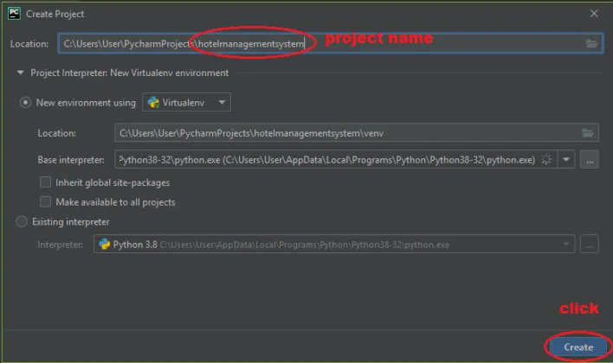

* **Step 2: Create a Python File.**

Second step after creating a project name, “**right**” click the project name and the click “**New”** after that choose “**Python File** “.” after that choose “**Python File** “.” after that choose “**Python File** “.

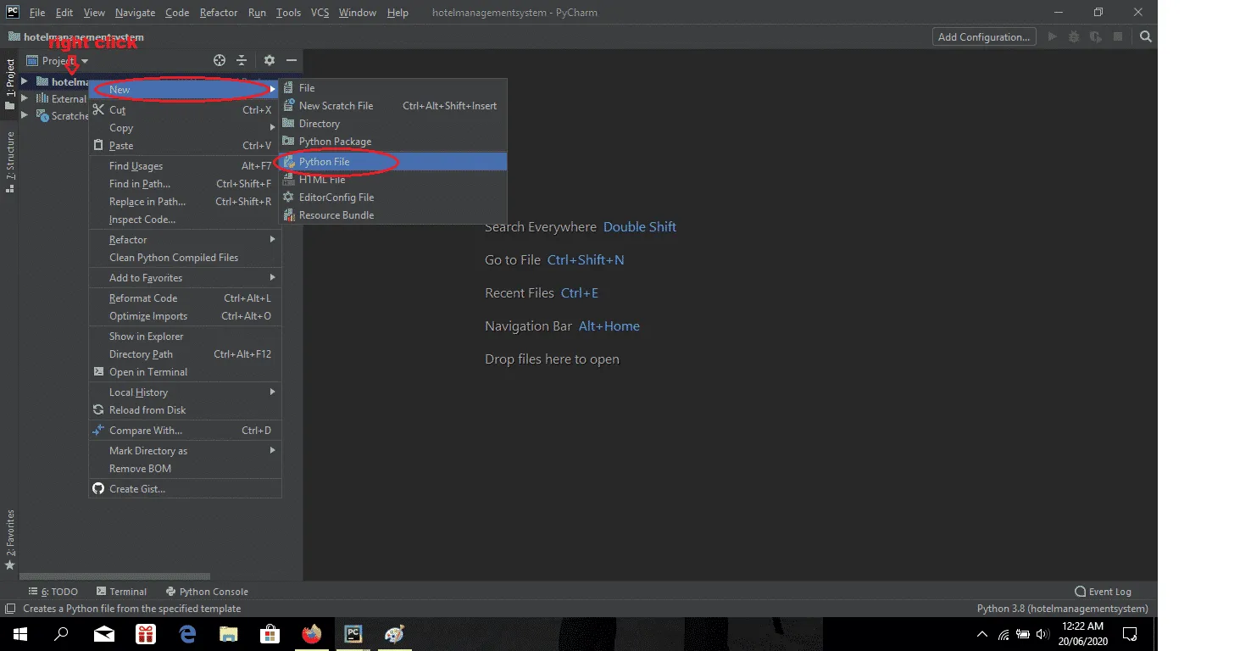

* **Step 3: Name the Python File.**

Third step after choose **Python File** name the file “**Hotel Management System**” and then click “**Enter** “.

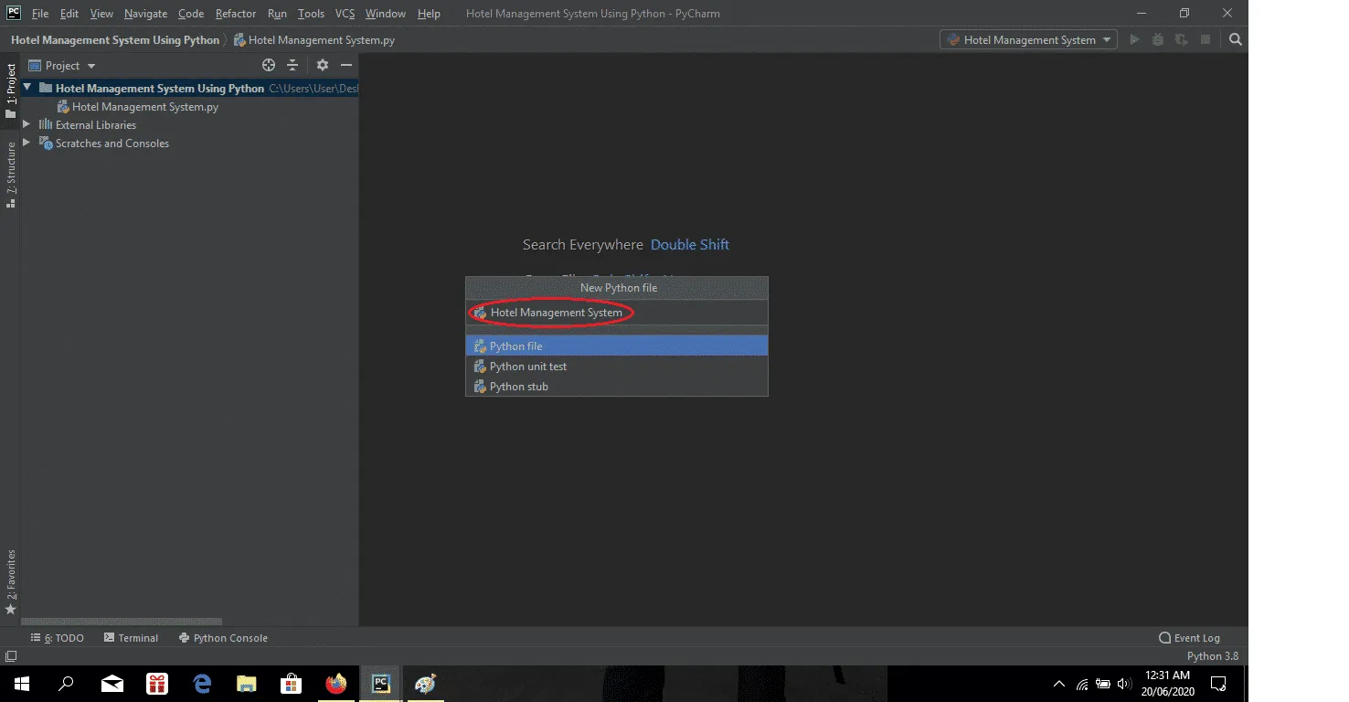

## 

## **Hotel Management Python Code**

class hotelfarecal:

def __init__(self,rt='',s=0,p=0,r=0,t=0,a=1800,name='',address='',cindate='',coutdate='',rno=101):

print ("\n\n*****WELCOME TO HEWING HOTEL*****\n")

self. rt=rt

self.r=r

self.t=t

self.p=p

self.s=s

self.a=a

self.name=name

self. address=address

self. cindate=cindate

self. coutdate=coutdate

self.rno=rno

def inputdata(self):

self.name=input ("\nEnter your name:")

self. address=input("\nEnter your address:")

self. cindate=input ("\nEnter your check in date:")

self. coutdate=input ("\nEnter your checkout date:")

print("Your room no.:",self.rno,"\n")

def roomrent(self): #sel1353

print ("We have the following rooms for you: -")

print ("1.  type A---->rs 6000 PN\-")

print ("2.  type B---->rs 5000 PN\-")

print ("3.  type C---->rs 4000 PN\-")

print ("4.  type D---->rs 3000 PN\-")

x=int (input ("Enter Your Choice Please->"))

n=int (input ("For How Many Nights Did You Stay:"))

if(x==1):

print ("you have opted room type A")

self. s=6000*n

elif (x==2):

print ("you have opted room type B")

self. s=5000*n

elif (x==3):

print ("you have opted room type C")

self. s=4000*n

elif (x==4):

print ("you have opted room type D")

self. s=3000*n

else:

print ("please choose a room")

print ("your room rent is = “, self. s,"\n")

def restaurentbill(self):

print ("*****RESTAURANT MENU*****")

print ("1. water----->Rs20","2. tea----->Rs10","3. breakfast combo--->Rs90","4. lunch---->Rs110","5. dinner--->Rs150","6. Exit")

while (1):

c=int (input ("Enter your choice:"))

if (c==1):

d=int (input ("Enter the quantity:"))

self.r=self.r+20*d

elif (c==2):

d=int (input ("Enter the quantity:"))

self.r=self.r+10*d

elif (c==3):

d=int (input ("Enter the quantity:"))

self.r=self.r+90*d

elif (c==4):

d=int (input ("Enter the quantity:"))

self.r=self.r+110*d

elif (c==5):

d=int (input ("Enter the quantity:"))

self.r=self.r+150*d

elif (c==6):

break;

else:

print ("Invalid option")

print ("Total food Cost=Rs”, self.r,"\n")

def laundrybill(self):

print ("******LAUNDRY MENU*******")

print ("1. Shorts----->Rs3","2. Trousers----->Rs4","3. Shirt--->Rs5","4. Jeans---->Rs6","5. Girlsuit--->Rs8","6. Exit")

while (1):

#brought to you by code-projects.org

e=int (input ("Enter your choice:"))

if (e==1):

f=int (input ("Enter the quantity:"))

self.t=self.t+3*f

elif (e==2):

f=int (input ("Enter the quantity:"))

self.t=self.t+4*f

elif (e==3):

f=int (input ("Enter the quantity:"))

self.t=self.t+5*f

elif (e==4):

f=int (input ("Enter the quantity:"))

self.t=self.t+6*f

elif (e==5):

f=int (input ("Enter the quantity:"))

self.t=self.t+8*f

elif (e==6):

break;

else:

print ("Invalid option")

print ("Total Laundary Cost=Rs",self.t,"\n")

def gamebill(self):

print ("******GAME MENU*******")

print ("1. Table tennis----->Rs60","2.Bowling----->Rs80","3.Snooker--->Rs70","4.Video games---->Rs90","5.Pool--->Rs50==6","6.Exit")

while (1):

g=int (input ("Enter your choice:"))

if (g==1):

h=int (input ("No. of hours:"))

self.p=self.p+60*h

elif (g==2):

h=int (input ("No. of hours:"))

self.p=self.p+80*h

elif (g==3):

h=int (input ("No. of hours:"))

self.p=self.p+70*h

elif (g==4):

h=int (input ("No. of hours:"))

self.p=self.p+90*h

elif (g==5):

h=int (input ("No. of hours:"))

self.p=self.p+50*h

elif (g==6):

break;

else:

print ("Invalid option")

print ("Total Game Bill=Rs”, self.p,"\n")

def display(self):

print ("******HOTEL BILL******")

print ("Customer details:")

print ("Customer name:”, self.name)

print ("Customer address:”, self. address)

print ("Check in date:”, self. cindate)

print ("Check out date”, self. coutdate)

print ("Room no.”, self.rno)

print ("Your Room rent is:”, self.s)

print ("Your Food bill is:”, self.r)

print ("Your laundary bill is:”, self.t)

print ("Your Game bill is:”, self.p)

self. rt=self. s+self.t+self.p+self. rt

print ("Your sub total bill is:",self.rt)

print ("Additional Service Charges is”, self.a)

print ("Your grandtotal bill is:”, self.rt+self.a,"\n")

self.rno+=1

def main ():

a=hotelfarecal ()

while (1):

print ("1. Enter Customer Data")

print ("2. Calculate rommrent")

print ("3. Calculate restaurant bill")

print ("4. Calculate laundry bill")

print ("5. Calculate gamebill")

print ("6. Show total cost")

print ("7. EXIT")

b=int (input ("\nEnter your choice:"))

if (b==1):

a. inputdata ()

if (b==2):

a. roomrent ()

if (b==3):

a. restaurentbill ()

if (b==4):

a. laundrybill ()

if (b==5):

a. gamebill ()

if (b==6):

a. display ()

if (b==7):

quit ()

**OUTPUT**

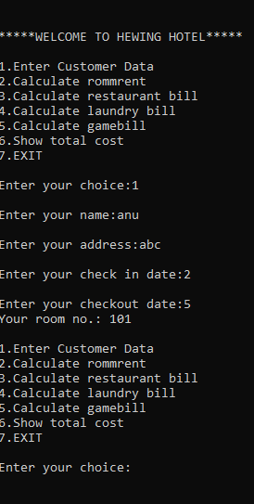

**REFRENCES**

* [Hotel Management System Project In Python With Source Code (itsourcecode.com)](https://itsourcecode.com/free-projects/python-projects/hotel-management-system-project-in-python/#:~:text=Steps%20on%20how%20to%20create%20a%20Hotel%20Management,...%204%20Step%204%3A%20The%20actual%20code.%20)
* [What Is Hotel Management? Definition and Duties | Indeed.com](https://www.indeed.com/career-advice/finding-a-job/hotel-management)